Classes (visibility mode,data member,member functions,objects)

In C++

1-Wap to swap two numbers using Classes of C++.

// Online C++ compiler to run C++ program online

#include <iostream>

using namespace std;

class A{

public:

int a,b,temp;

public:

void swap1(int \*a1,int \*b1)

{

int temp;

temp=\*a1;

\*a1=\*b1;

\*b1=temp;

}

};

int main() {

// Write C++ code here

A s;

cout<<"Enter values to swap";

cin>>s.a>>s.b;

s.swap1(&s.a,&s.b);

cout<<"values after swap";

cout<<s.a<<s.b;

return 0;

}

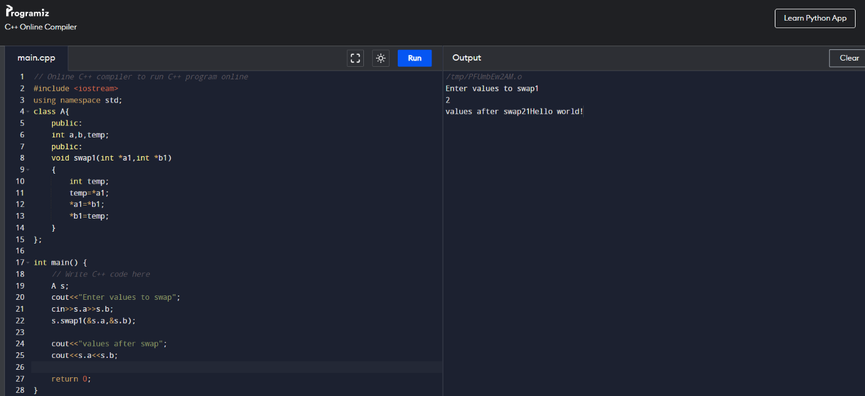

2 to check prime or not

//input 5

//output not prime

#include <iostream>

using namespace std;

class A{

public:

int a;

void fun(int a1)

{

int i,flag=0;

for(i=2;i<a1;i++)

{

if(a1%i==0)

{

flag=1;

break;

}

}

if(flag==0)

cout<<"Prime number";

else

cout<<"Not prime";

}

};

int main() {

// Write C++ code here

A s;

cout<<"Enter no to check prime or not";

cin>>s.a;

s.fun(s.a);

//cout<<"values after swap";

//cout<<s.a<<s.b;

return 0;

}

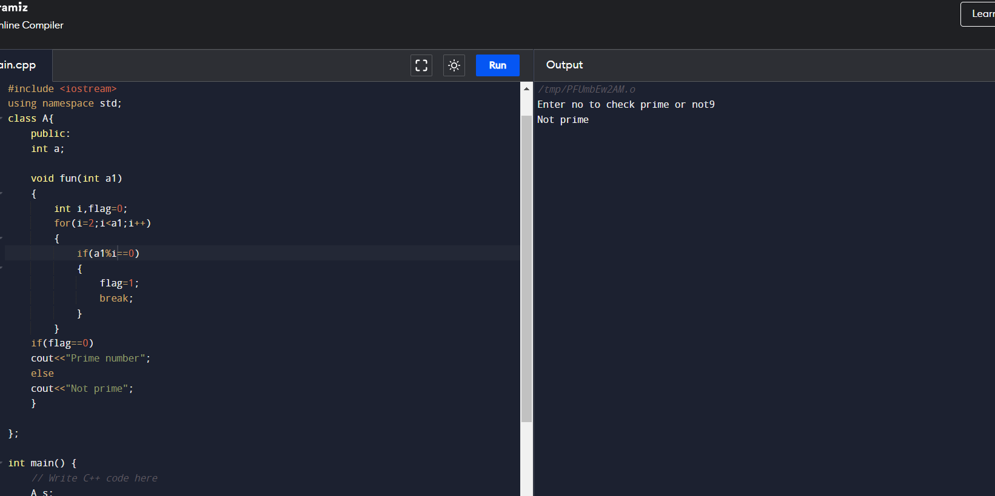

3 Area of circle

//Area of cirlce

//input 5

//output =78.50

//area of circle

#include <iostream>

using namespace std;

class A{

public:

float a,area=0;

void getdata();

void fun(int);

void display();

};

void A::getdata()

{

cout<<"Enter data\n";

cin>>a;

}

void A::fun(int a1)

{

area=3.14 \* a1 \* a1;

}

void A::display()

{

cout<<"Area of cirlce"<<area;

}

int main() {

// Write C++ code here

A s;

s.getdata();

s.fun(s.a);

s.display();

//cout<<"values after swap";

//cout<<s.a<<s.b;

return 0;

}

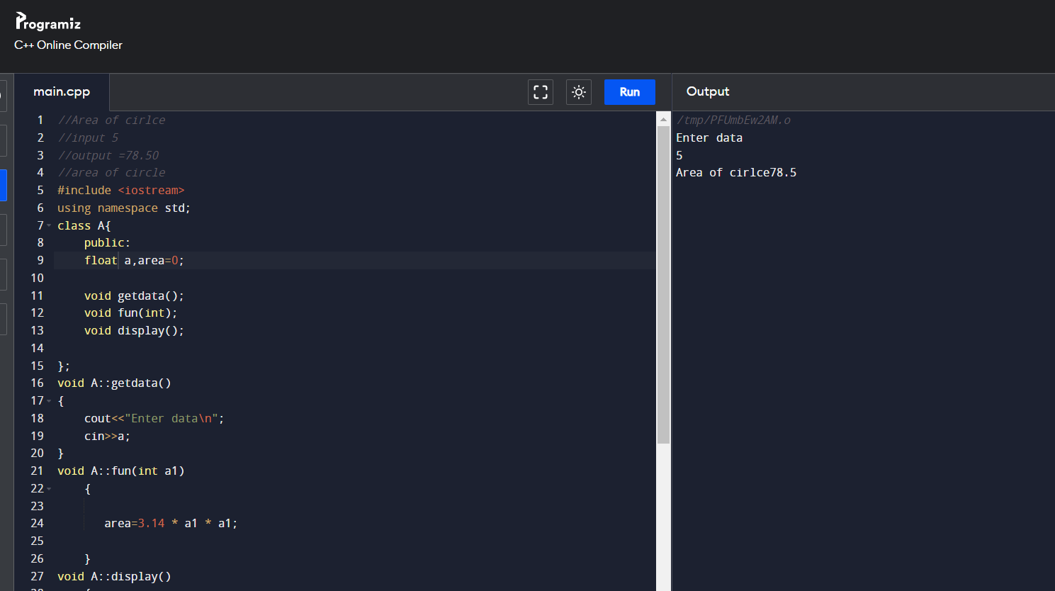

//4 Area of rectangle

//Area of cirlce

//input 5

//output =78.50

//area of circle

#include <iostream>

using namespace std;

class A{

public:

float b,area=0,l;

void getdata();

void fun(float,float);

void display();

};

void A::getdata()

{

cout<<"Enter data\n";

cin>>l>>b;

}

void A::fun(float a1,float b1)

{

area=a1\*b1;

}

void A::display()

{

cout<<"Area of rectangle"<<area;

}

int main() {

// Write C++ code here

A s;

s.getdata();

s.fun(s.l,s.b);

s.display();

//cout<<"values after swap";

//cout<<s.a<<s.b;

return 0;

}

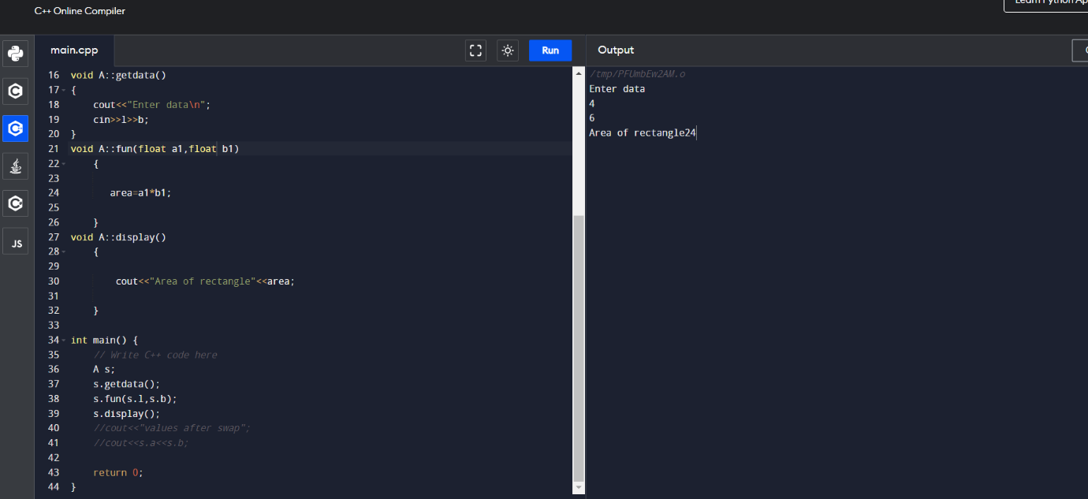

// 5 Area of square

//input 5

//output =25

//area of circle

#include <iostream>

using namespace std;

class A{

public:

float a,area=0;

void getdata();

void fun(float);

void display();

};

void A::getdata()

{

cout<<"Enter data\n";

cin>>a;

}

void A::fun(float a1)

{

area=a1\*a1;

}

void A::display()

{

cout<<"Area of square :"<<area;

}

int main() {

// Write C++ code here

A s;

s.getdata();

s.fun(s.a);

s.display();

//cout<<"values after swap";

//cout<<s.a<<s.b;

return 0;

}

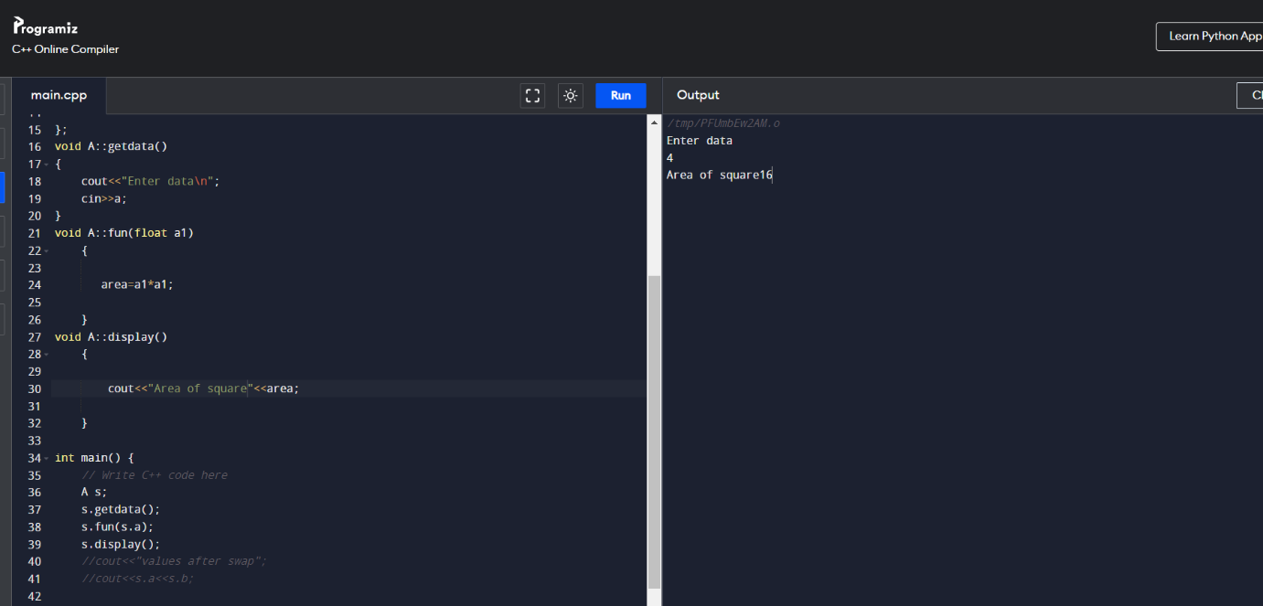

// 6 find simple interest

//input 2000 .03 2

//output =120

#include <iostream>

using namespace std;

class A{

public:

float p,r,t,si=0,amount;

void getdata();

void fun();

void display();

};

void A::getdata()

{

cout<<"Enter data\n";

cin>>p>>r>>t;

}

void A::fun()

{

si=p\*r\*t;

amount=p +si;

}

void A::display()

{

cout<<"simple interest generateed :"<<si<<"and amount"<<amount;

}

int main() {

// Write C++ code here

A s;

s.getdata();

s.fun();

s.display();

//cout<<"values after swap";

//cout<<s.a<<s.b;

return 0;

}

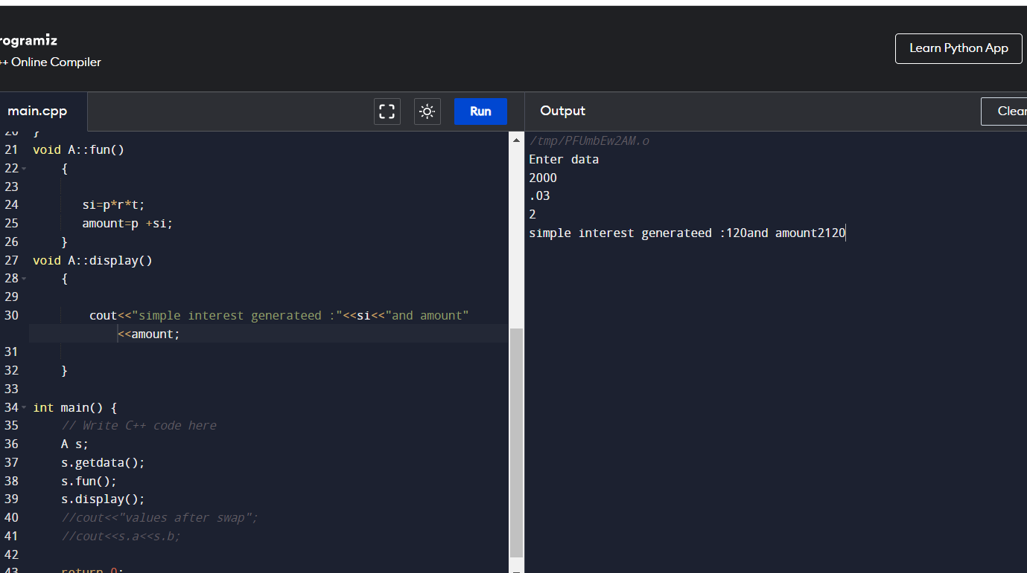

// 7 find compund interest

//input 2000 3 2

//output =2121.8

#include <iostream>

#include<math.h>

using namespace std;

class A{

public:

float p,r,t,ci=0,amount;

void getdata();

void fun();

void display();

};

void A::getdata()

{

cout<<"Enter data\n";

cin>>p>>r>>t;

}

void A::fun()

{

ci=p\*pow((1+r/100),t);

amount=p +ci;

}

void A::display()

{

cout<<"compound interest generateed :"<<ci<<"and amount"<<amount;

}

int main() {

// Write C++ code here

A s;

s.getdata();

s.fun();

s.display();

//cout<<"values after swap";

//cout<<s.a<<s.b;

return 0;

}

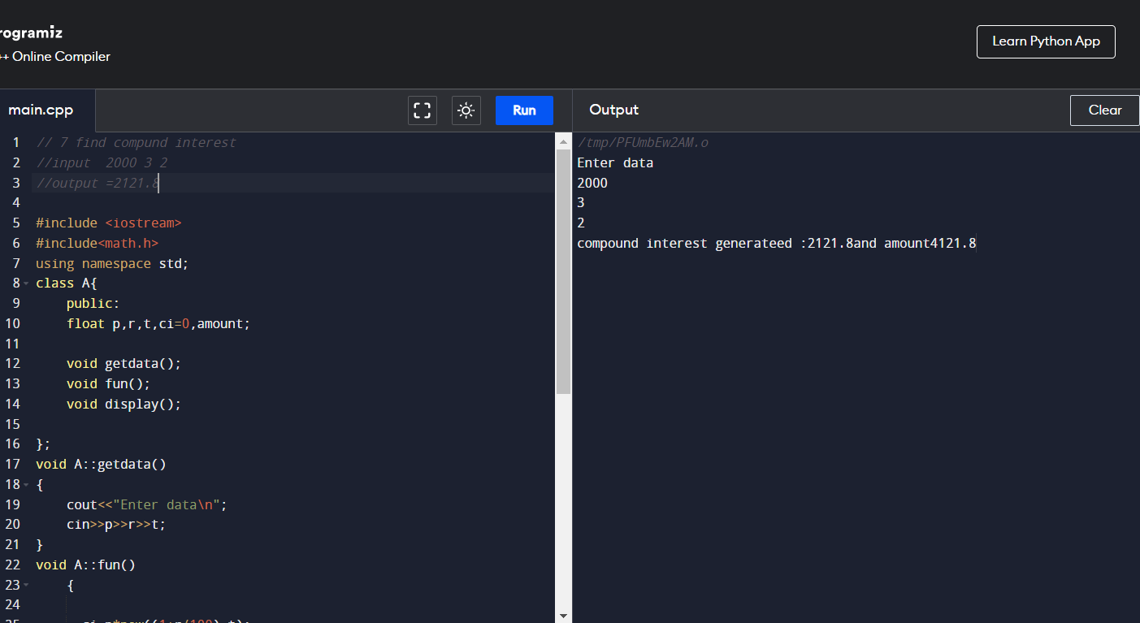

// 8 find number is even or odd

//input 2

//output =no is even

#include <iostream>

#include<math.h>

using namespace std;

class A{

public:

int a,flag=0;

void getdata();

void fun();

void display();

};

void A::getdata()

{

cout<<"Enter data\n";

cin>>a;

}

void A::fun()

{

if(a%2==0)

flag=1;

}

void A::display()

{

if(flag==1)

cout<<"no is even";

else

cout<<"no is odd";

}

int main() {

// Write C++ code here

A s;

s.getdata();

s.fun();

s.display();

//cout<<"values after swap";

//cout<<s.a<<s.b;

return 0;

}

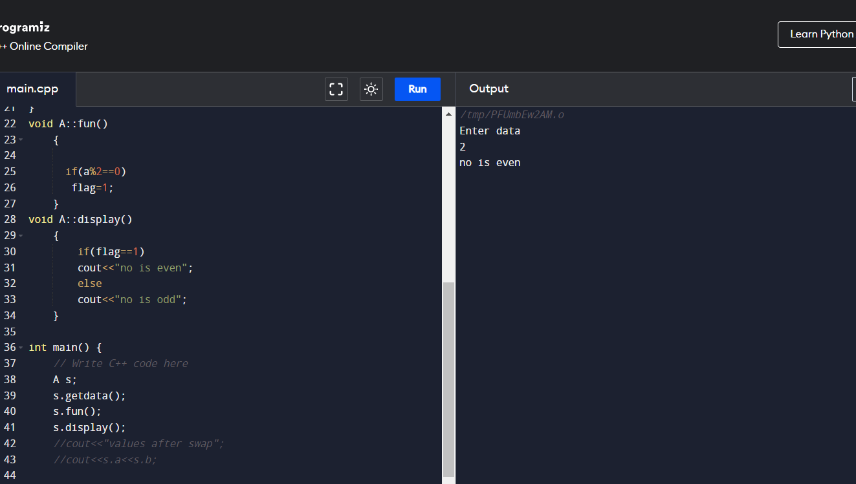

// 9 In a givn range, print calculated number is even or odd

//input 5

//output =2 is even,4 is even

#include <iostream>

#include<math.h>

using namespace std;

class A{

public:

int a,flag=0,i;

void getdata();

void fun();

void display();

};

void A::getdata()

{

cout<<"Enter data\n";

cin>>a;

}

void A::fun()

{

for(i=0;i<a;i++)

{

if(i%2==0)

flag=1;

display();

flag=0;

}

}

void A::display()

{

if(flag==1)

cout<<i<<" is even ";

else

cout<<i<<" is odd ";

}

int main() {

// Write C++ code here

A s;

s.getdata();

s.fun();

s.display();

//cout<<"values after swap";

//cout<<s.a<<s.b;

return 0;

}

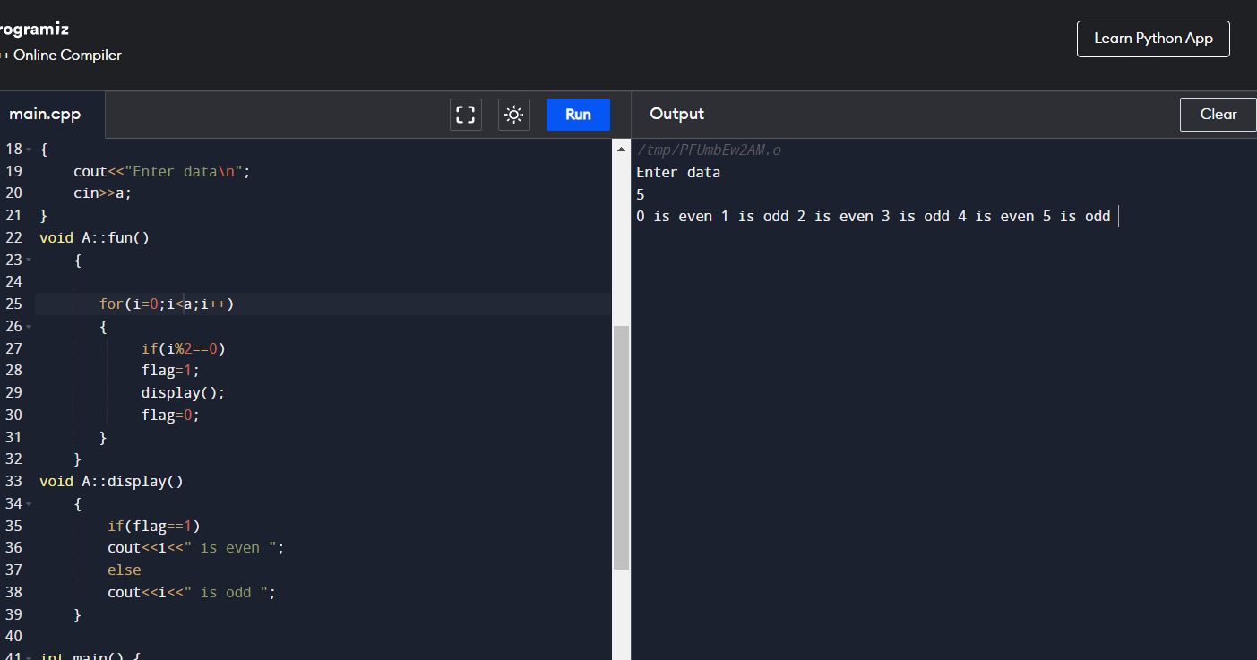

// 10 In a givn range, print calculated number is even or odd

//input 5

//output =2 is even,4 is even

#include <iostream>

#include<math.h>

using namespace std;

class A{

public:

int a,flag=0,i;

void getdata();

void fun();

void display();

};

void A::getdata()

{

cout<<"Enter data\n";

cin>>a;

}

void A::fun()

{

for(i=0;i<a;i++)

{

if(i%2==0)

flag=1;

display();

flag=0;

}

}

void A::display()

{

if(flag==1)

cout<<i<<" is even ";

else

cout<<i<<" is odd ";

}

int main() {

// Write C++ code here

A s;

s.getdata();

s.fun();

s.display();

//cout<<"values after swap";

//cout<<s.a<<s.b;

return 0;

}

// 11 convert m to km and delivery condition

//input 6000m

//output =6=km,yes delievery available

#include <iostream>

#include<math.h>

using namespace std;

class A{

public:

int a,b;

void getdata();

void fun();

void display();

};

void A::getdata()

{

cout<<"Enter data\n";

cin>>a;

}

void A::fun()

{

b=a/1000 ;

}

void A::display()

{

if(b>5)

cout<<" km is "<<b<<"delieverable";

else

cout<<" not delieverable ";

}

int main() {

// Write C++ code here

A s;

s.getdata();

s.fun();

s.display();

//cout<<"values after swap";

//cout<<s.a<<s.b;

return 0;

}

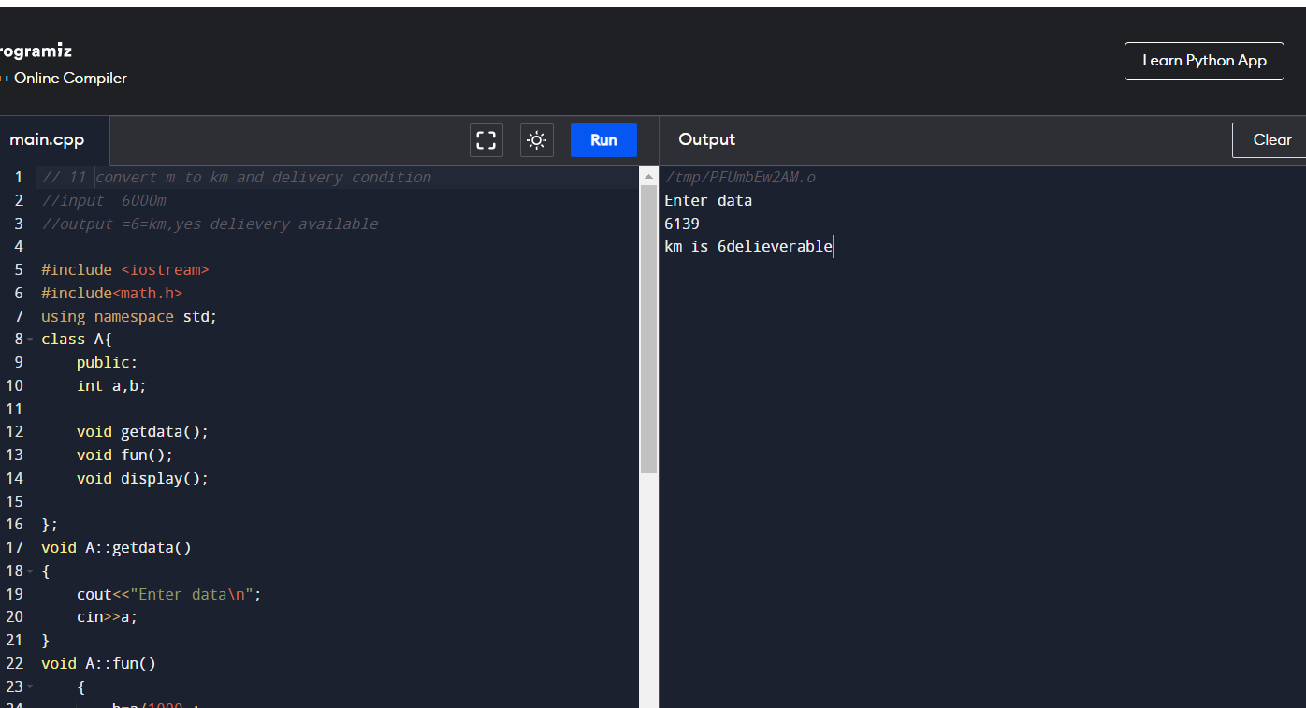

// 12 find factorial

//input 5

//output = factorial is 120

#include <iostream>

#include<math.h>

using namespace std;

class A{

public:

int number,res=1;

void getdata();

void fun();

void display();

};

void A::getdata()

{

cout<<"Enter data\n";

cin>>number;

}

void A::fun()

{

int i;

int t=number;

for(i=0;i<t;i++)

{

res=number\*res;

number=number-1;

}

}

void A::display()

{

cout<<" Factorial is "<<res;

}

int main() {

// Write C++ code here

A s;

s.getdata();

s.fun();

s.display();

//cout<<"values after swap";

//cout<<s.a<<s.b;

return 0;

}

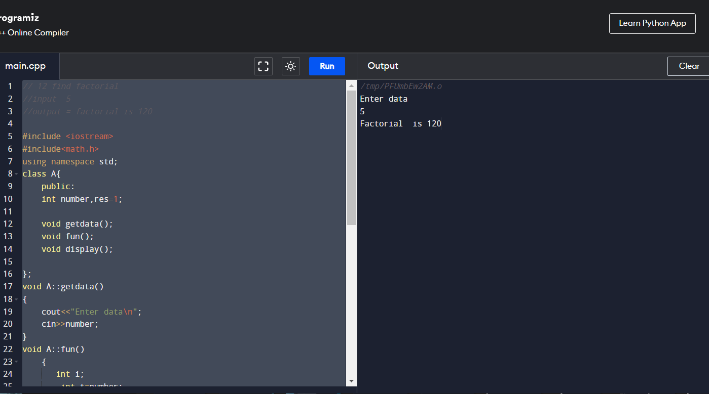

// 13 In a range print the calcultaed factorial

//input 5

//output = factorial of 1 is 1, factorial of 2 is 2 ..factroial of 5 is 120

#include <iostream>

#include<math.h>

using namespace std;

class A{

public:

int n,i,j,fact=0;

void getdata();

void fun();

void display();

};

void A::getdata()

{

cout<<"Enter data\n";

cin>>n;

}

void A::fun()

{

for(i=1;i<=n;i++)

{

fact=1;

for(j=1;j<=i;j++)

{

fact=fact\*j;

}

display();

fact=0;

}

}

void A::display()

{

cout<<" Factorial of "<<i<<" are "<<fact <<"\n";

}

int main() {

// Write C++ code here

A s;

s.getdata();

s.fun();

s.display();

//cout<<"values after swap";

//cout<<s.a<<s.b;

return 0;

}

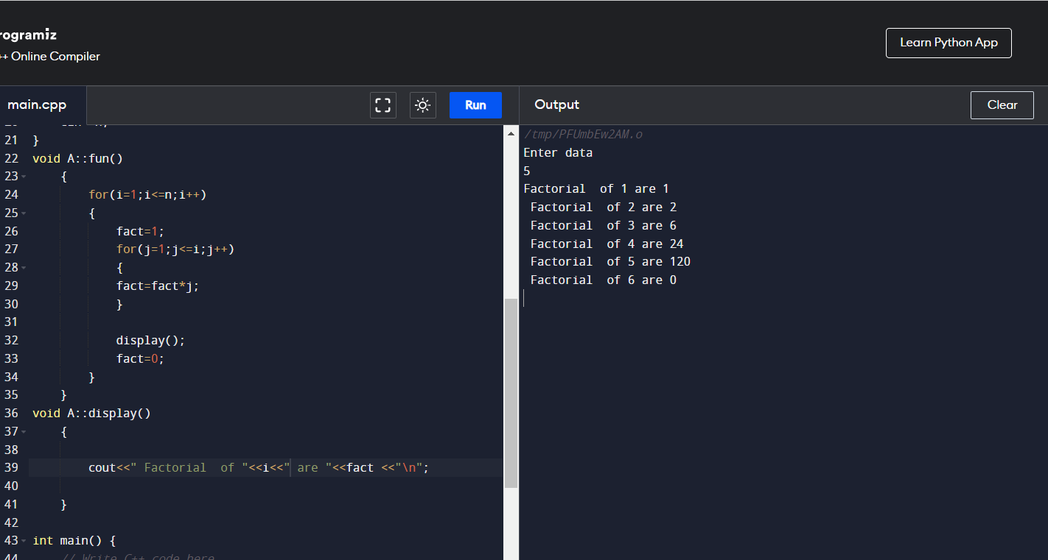

// 17 print number of digits

//input 121

//output = 3

#include <iostream>

#include<math.h>

using namespace std;

class A{

public:

int n,r,count=0,temp2,i;

void getdata();

void fun();

void display();

};

void A::getdata()

{

cout<<"Enter data\n";

cin>>n;

}

void A::fun()

{

temp2=n;;

while(temp2>0)

{

r=temp2%10;

count++ ;

temp2=temp2/10;

}

}

void A::display()

{

cout<<n<<" digits count is \n"<<count;

// else

//cout<<i<<"is not aremstrog numbr\n";

}

int main() {

// Write C++ code here

A s;

s.getdata();

s.fun();

s.display();

//cout<<"values after swap";

//cout<<s.a<<s.b;

return 0;

}

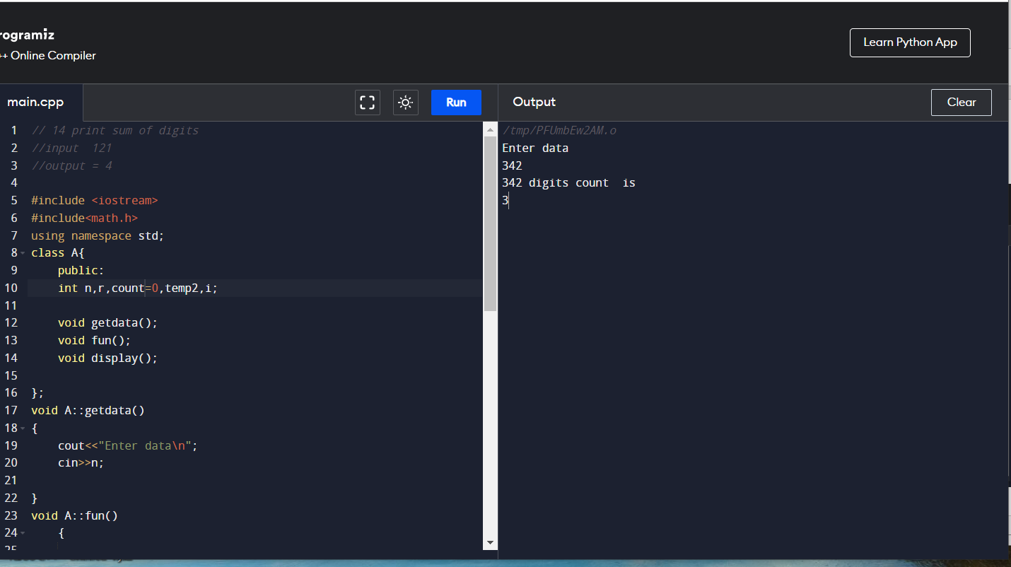

// 14 print sum of digits

//input 121

//output = 4

#include <iostream>

#include<math.h>

using namespace std;

class A{

public:

int n,r,sum=0,temp2,i;

void getdata();

void fun();

void display();

};

void A::getdata()

{

cout<<"Enter data\n";

cin>>n;

}

void A::fun()

{

temp2=n;;

while(temp2>0)

{

r=temp2%10;

sum=sum+r;

temp2=temp2/10;

}

}

void A::display()

{

cout<<n<<" digits sum is \n"<<sum;

// else

//cout<<i<<"is not aremstrog numbr\n";

}

int main() {

// Write C++ code here

A s;

s.getdata();

s.fun();

s.display();

//cout<<"values after swap";

//cout<<s.a<<s.b;

return 0;

}

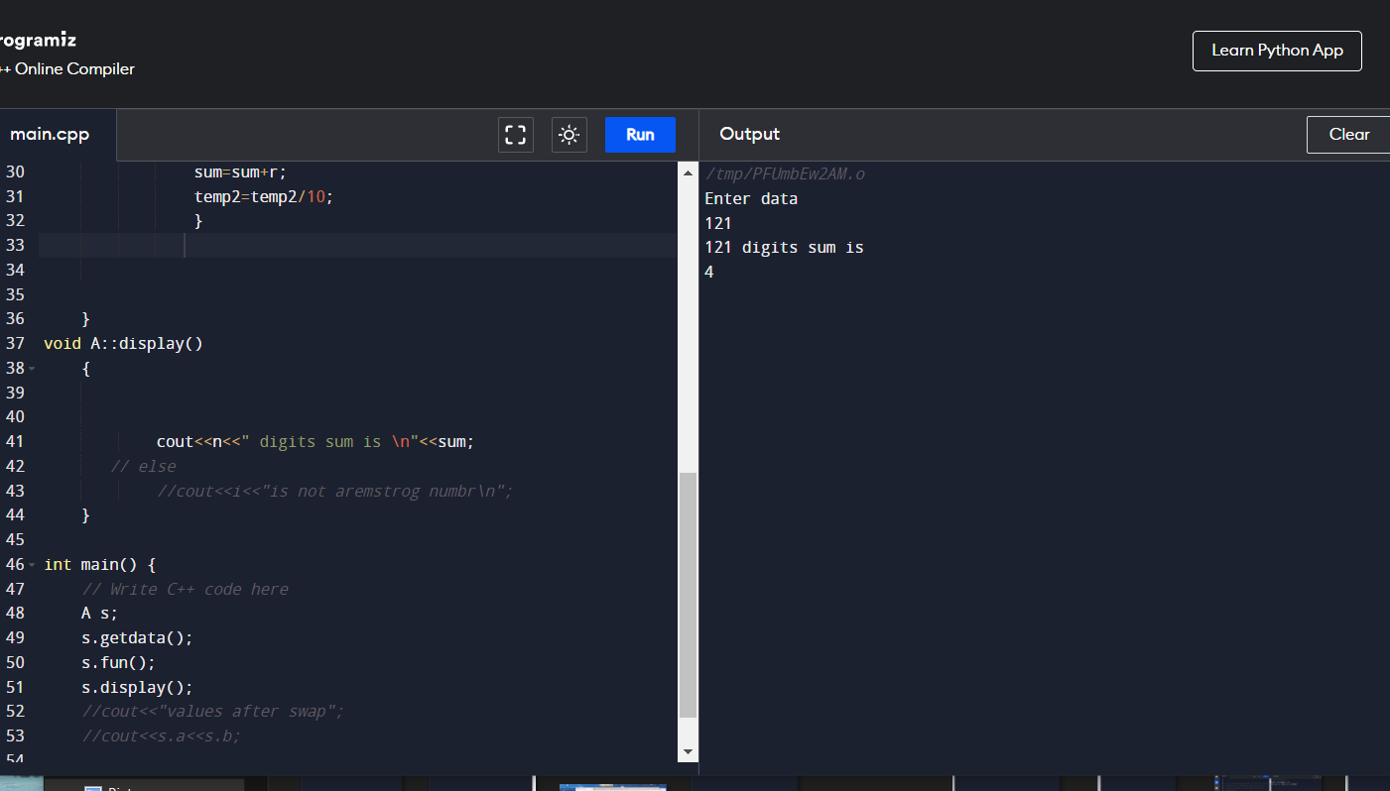

// 15 check armstrong

//input 121

//output = aremstrog numbr

#include <iostream>

#include<math.h>

using namespace std;

class A{

public:

int n,r,sum=0,temp;

void getdata();

void fun();

void display();

};

void A::getdata()

{

cout<<"Enter data\n";

cin>>n;

temp=n;

}

void A::fun()

{

while(n>0)

{

r=n%10;

sum=sum+(r\*r\*r);

n=n/10;

}

}

void A::display()

{

if(temp==sum)

cout<<" aremstrog numbr";

}

int main() {

// Write C++ code here

A s;

s.getdata();

s.fun();

s.display();

//cout<<"values after swap";

//cout<<s.a<<s.b;

return 0;

}

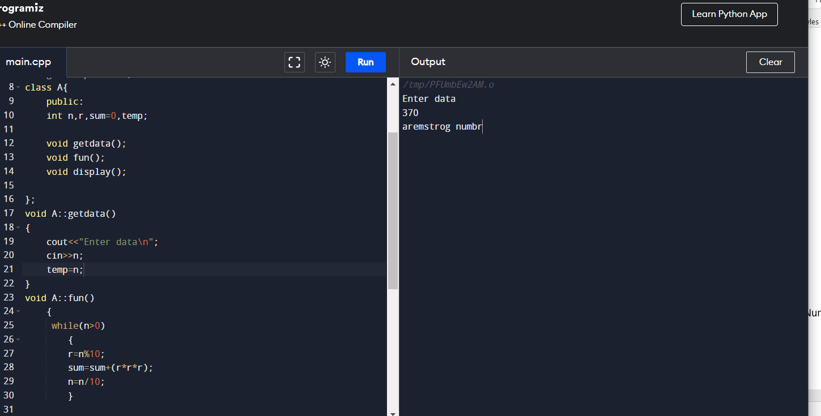

// 16 check armstrong in range

//input 121

//output = aremstrog numbr

#include <iostream>

#include<math.h>

using namespace std;

class A{

public:

int n,r,sum=0,temp,i,temp2;

void getdata();

void fun();

void display();

};

void A::getdata()

{

cout<<"Enter data\n";

cin>>n;

temp=n;

}

void A::fun()

{

for(i=1;i<=n;i++)

{

temp2=i;;

while(temp2>0)

{

r=temp2%10;

sum=sum+(r\*r\*r);

temp2=temp2/10;

}

display();

sum=0;

}

}

void A::display()

{

if(temp==sum)

cout<<i<<"is aremstrog numbr\n";

// else

//cout<<i<<"is not aremstrog numbr\n";

}

int main() {

// Write C++ code here

A s;

s.getdata();

s.fun();

s.display();

//cout<<"values after swap";

//cout<<s.a<<s.b;

return 0;

}

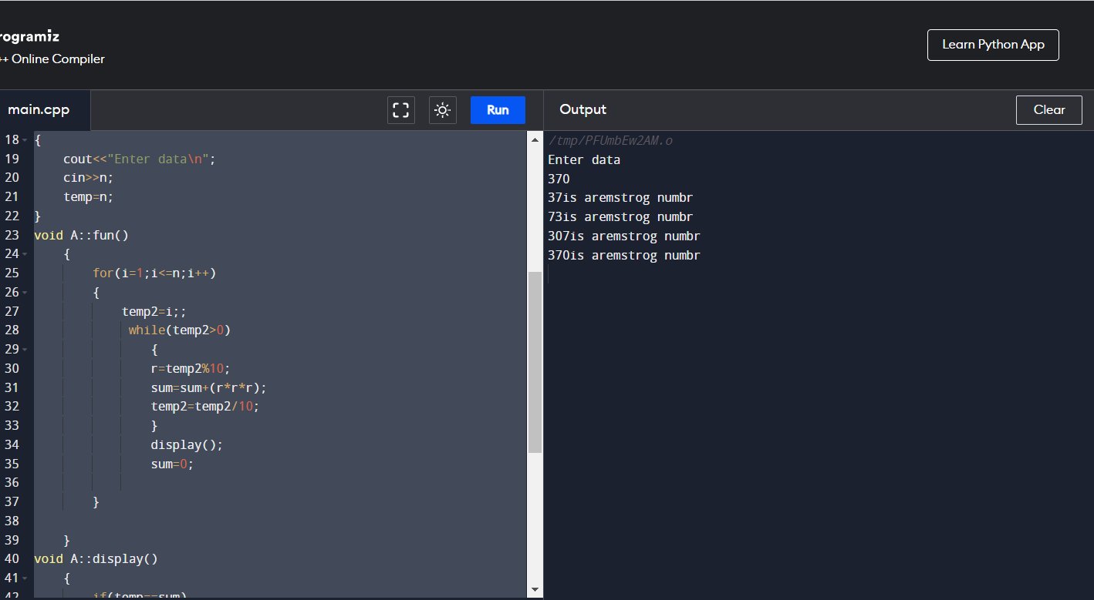

// 18 print reverse of digits

//input 1234

//output = 4321

#include <iostream>

#include<math.h>

using namespace std;

class A{

public:

int n,r,s=0,temp2,i;

void getdata();

void fun();

void display();

};

void A::getdata()

{

cout<<"Enter data\n";

cin>>n;

}

void A::fun()

{

temp2=n;;

while(temp2>0)

{

r=temp2%10;

s=s\*10 +r;

temp2=temp2/10;

}

}

void A::display()

{

cout<<n<<" digits reverse is \n"<<s;

// else

//cout<<i<<"is not aremstrog numbr\n";

}

int main() {

// Write C++ code here

A s;

s.getdata();

s.fun();

s.display();

//cout<<"values after swap";

//cout<<s.a<<s.b;

return 0;

}

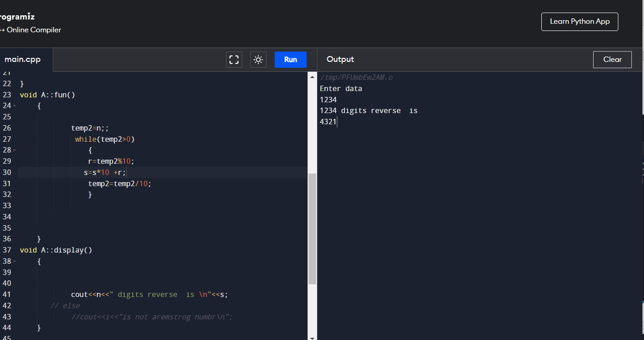

Array programs using classes

// 19 input values in array and print them

//input 1 2 3 4

//output = 12 3 4

#include <iostream>

#include<math.h>

using namespace std;

class A{

public:

int i,n,temp=0;

void getdata();

void fun();

void display();

};

void A::getdata()

{

cout<<"Enter total no of values in array\n";

cin>>n;

int arr[n];

cout<<"Enter values in array\n";

for(i=0;i<n;i++)

{

cin>>arr[i];

}

for(i=0;i<n;i++)

{

temp=arr[i];

display();

}

}

void A::fun()

{

//display();

}

void A::display()

{

cout<<"\nValues of arraty at index"<<i<<"are :"<<temp;

//cout<<i<<"is not aremstrog numbr\n";

}

int main() {

// Write C++ code here

A s;

s.getdata();

s.fun();

s.display();

//cout<<"values after swap";

//cout<<s.a<<s.b;

return 0;

}

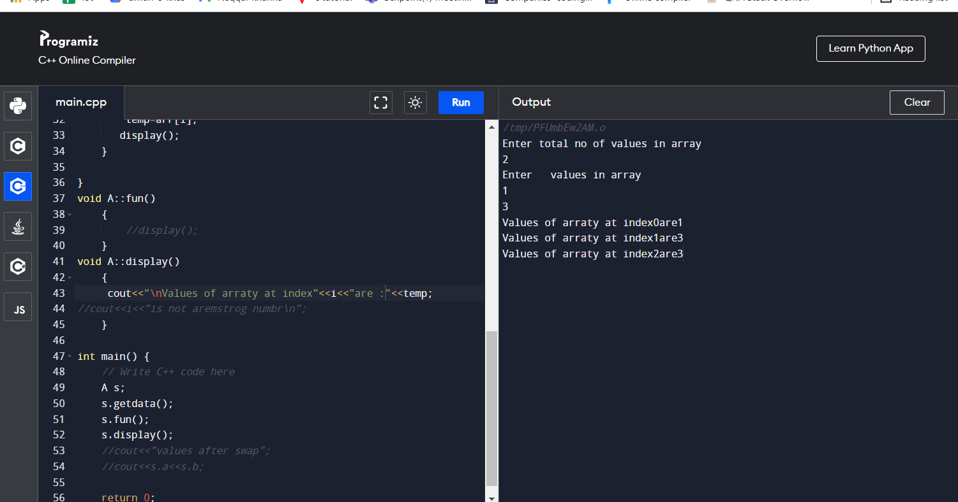

// 20 sum and avergage of input values in array and print them

//input 1 8

//output = sum is 9 , avg is 4

#include <iostream>

#include<math.h>

using namespace std;

class A{

public:

int i,n,temp=0,sum=0,avg=0;

void getdata();

void fun();

void display();

};

void A::getdata()

{

cout<<"Enter total no of values in array\n";

cin>>n;

int arr[n];

cout<<"Enter values in array\n";

for(i=0;i<n;i++)

{

cin>>arr[i];

sum=sum+arr[i];

}

for(i=0;i<n;i++)

{

temp=arr[i];

display();

}

}

void A::fun()

{

avg=sum/n;

cout<<"sumof above number is "<<sum;

cout<<"avergage of above number is "<<avg;

}

void A::display()

{

cout<<"\nValues of arraty at index"<<i<<"are :"<<temp;

//cout<<i<<"is not aremstrog numbr\n";

}

int main() {

// Write C++ code here

A s;

s.getdata();

s.fun();

//cout<<"values after swap";

//cout<<s.a<<s.b;

return 0;

}

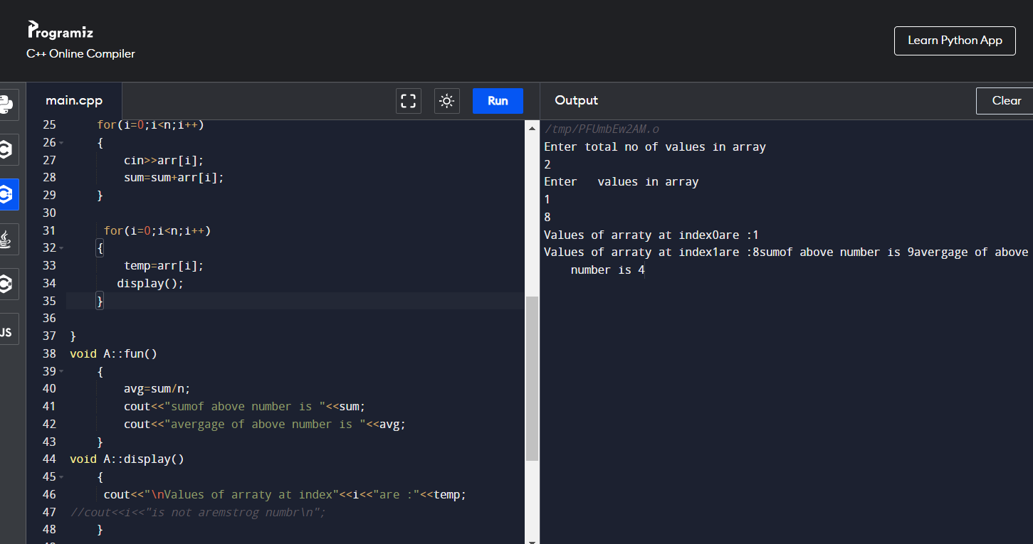

// 21 poistion of values in array and print them

//input 1

//output = position of 1 is

#include <iostream>

#include<math.h>

using namespace std;

class A{

public:

int i,n,f=0;

void getdata();

void fun();

void display();

};

void A::getdata()

{

cout<<"Enter total no of values in array\n";

cin>>n;

int arr[n];

cout<<"Enter values in array\n";

for(i=0;i<n;i++)

{

cin>>arr[i];

}

cout<<"enter the no to found";

cin>>f;

for(i=0;i<n;i++)

{

if(f=arr[i]);

display();

}

}

void A::fun()

{

}

void A::display()

{

cout<<"\nValues of arraty at index"<<i<<"are :"<<f;

//cout<<i<<"is not aremstrog numbr\n";

}

int main() {

// Write C++ code here

A s;

s.getdata();

s.fun();

//cout<<"values after swap";

//cout<<s.a<<s.b;

return 0;

}

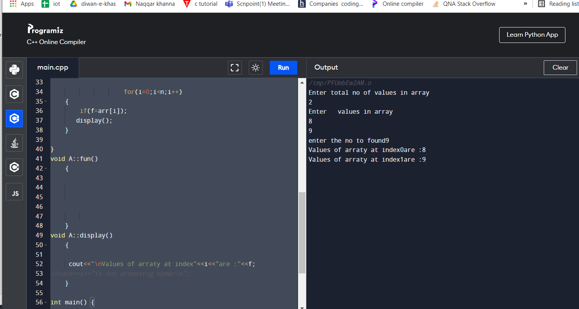

// 21 Sort input values in array in ascending order and print them

//input 5

// 5 3 4 2 1

//output =1 2 3 4 5

#include<iostream>

#include<math.h>

using namespace std;

class A{

public:

int i, j, a, n;

void getdata();

void fun();

void display();

};

void A::getdata()

{

cout<<"Enter total no of values in array\n";

cin>>n;

int number[30];

cout<<"Enter values in array\n";

for(i=0;i<n;i++)

{

cin>>number[i];

}

for (i = 0; i < n; ++i)

{

for (j = i + 1; j < n; ++j)

{

if (number[i] > number[j])

{

a = number[i];

number[i] = number[j];

number[j] = a;

}

}

}

cout<<"ascendig order are\n";

for (i = 0; i < n; ++i)

{

cout<<number[i]<<"\n";

}

}

void A::fun()

{

}

void A::display()

{

//cout<<"ascendig order are\t"<<number[i];

//cout<<i<<"is not aremstrog numbr\n";

}

int main() {

// Write C++ code here

A s;

s.getdata();

//cout<<"values after swap";

//cout<<s.a<<s.b;

return 0;

}

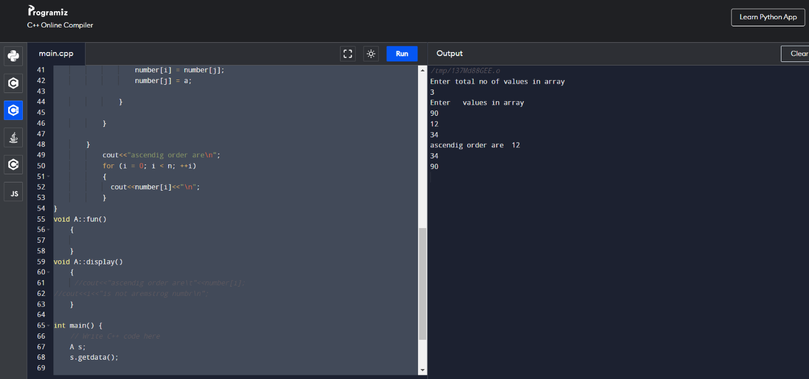

// 22 Sort input values in descending array and print them

//input 5

// 9 2001 2 3 8

//output =20001 9 8 3 2

#include<iostream>

#include<math.h>

using namespace std;

class A{

public:

int i, j, a, n;

void getdata();

void fun();

void display();

};

void A::getdata()

{

cout<<"Enter total no of values in array\n";

cin>>n;

int number[30];

cout<<"Enter values in array\n";

for(i=0;i<n;i++)

{

cin>>number[i];

}

for (i = 0; i < n; ++i)

{

for (j = i + 1; j < n; ++j)

{

if (number[i] < number[j])

{

a = number[i];

number[i] = number[j];

number[j] = a;

}

}

}

cout<<"descendig order are\n";

for (i = 0; i < n; ++i)

{

cout<<number[i]<<"\n";

}

}

void A::fun()

{

}

void A::display()

{

//cout<<"ascendig order are\t"<<number[i];

//cout<<i<<"is not aremstrog numbr\n";

}

int main() {

// Write C++ code here

A s;

s.getdata();

//cout<<"values after swap";

//cout<<s.a<<s.b;

return 0;

}

// 23 Count even numbers iin array and print them

//input 6

// 2 4 6 8 10 8

//output =even no are 5

#include<iostream>

#include<math.h>

using namespace std;

class A{

public:

int i, j, a, n,count=0;

void getdata();

void fun();

void display();

};

void A::getdata()

{

cout<<"Enter total no of values in array\n";

cin>>n;

int number[30];

cout<<"Enter values in array\n";

for(i=0;i<n;i++)

{

cin>>number[i];

if(number[i]%2==0)

{

count++;

}

}

cout<<"even number are \n";

cout<<count;

}

void A::fun()

{

}

void A::display()

{

//cout<<"ascendig order are\t"<<number[i];

//cout<<i<<"is not aremstrog numbr\n";

}

int main() {

// Write C++ code here

A s;

s.getdata();

//cout<<"values after swap";

//cout<<s.a<<s.b;

return 0;

}

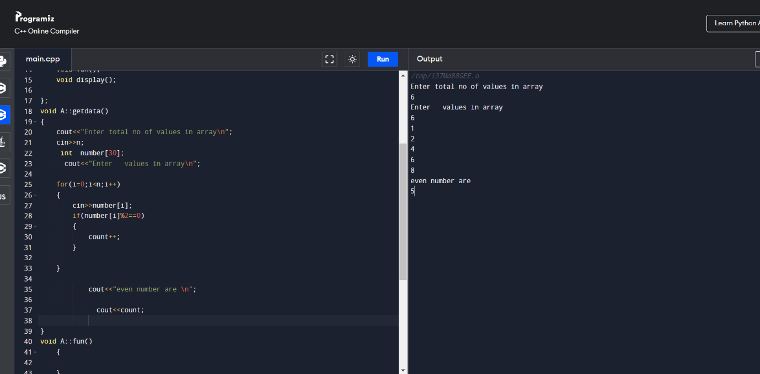

// 24 Count odd numbers iin array and print them

//input 6

// 1 3 5 8 9 8

//output =even no are 4

#include<iostream>

#include<math.h>

using namespace std;

class A{

public:

int i, j, a, n,count=0;

void getdata();

void fun();

void display();

};

void A::getdata()

{

cout<<"Enter total no of values in array\n";

cin>>n;

int number[30];

cout<<"Enter values in array\n";

for(i=0;i<n;i++)

{

cin>>number[i];

if(number[i]%2 != 0)

{

count++;

}

}

cout<<"Odd number are \n";

cout<<count;

}

void A::fun()

{

}

void A::display()

{

//cout<<"ascendig order are\t"<<number[i];

//cout<<i<<"is not aremstrog numbr\n";

}

int main() {

// Write C++ code here

A s;

s.getdata();

//cout<<"values after swap";

//cout<<s.a<<s.b;

return 0;

}

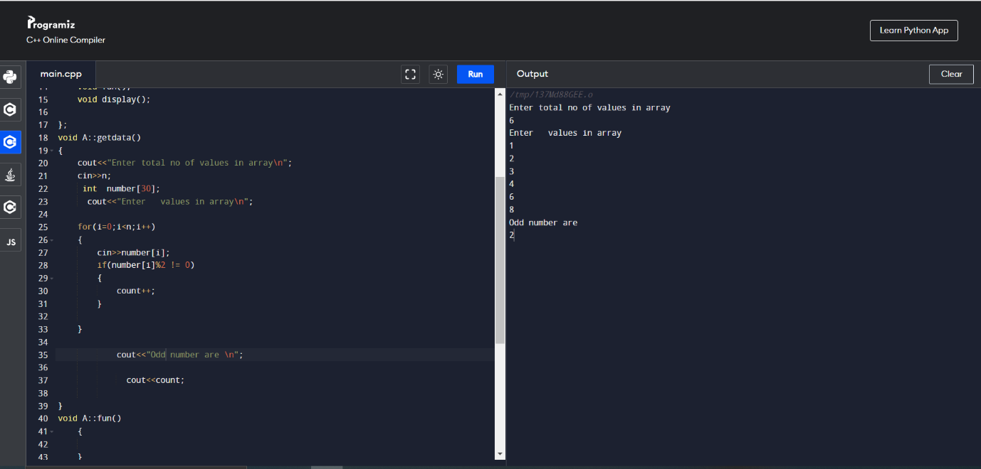

// 25 Count digits in each element in array and print them

//input 6

// 1 33 521 8011 9 82222

//output =digits are 1 2 3 4 1 5

#include<iostream>

#include<math.h>

using namespace std;

class A{

public:

int i, j, a, n,count=0,temp;

void getdata();

void fun();

void display();

};

void A::getdata()

{

cout<<"Enter total no of values in array\n";

cin>>n;

int number[30],countarr[30];

cout<<"Enter values in array\n";

for(i=0;i<n;i++)

{

cin>>number[i];

}

for(i=0;i<n;i++)

{

temp=number[i];

while(temp != 0)

{

count++;

temp=temp / 10;

}

countarr[i]=count;

count =0;

}

for(i=0;i<n;i++)

{

cout<<" at index "<<i<<" Digit count are"<<countarr[i];

}

}

void A::fun()

{

}

void A::display()

{

//cout<<"ascendig order are\t"<<number[i];

//cout<<i<<"is not aremstrog numbr\n";

}

int main() {

// Write C++ code here

A s;

s.getdata();

//cout<<"values after swap";

//cout<<s.a<<s.b;

return 0;

}

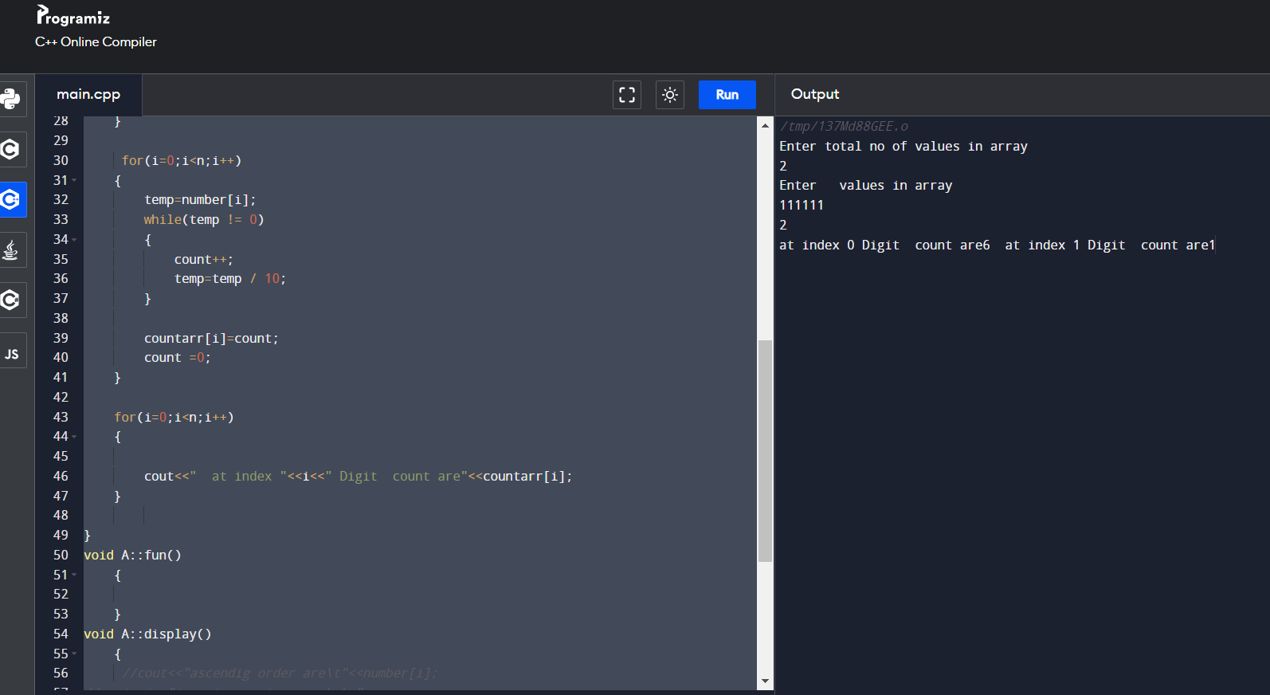

26 // 26 Check prime numbers iin array and print them

//input 6

// 1 2 3 7 9

//output =digits are 1 2 3 7 9

#include<iostream>

#include<math.h>

using namespace std;

class A

{

public:

int i, j, a, n,count=0,temp,flag=0;

void getdata();

void fun();

void display();

};

void A::getdata()

{

cout<<"Enter total no of values in array\n";

cin>>n;

int number[30];

cout<<"Enter values in array\n";

for(i=0;i<n;i++)

{

cin>>number[i];

}

for(i=0;i<n;i++)

{

count=0;

temp=number[i];

//1

flag=0;

if(temp ==1 || temp == 2)

{

count++;

}

else

{

for(j=2;j<=temp;j++) //

{

if( (temp %j == 0) )

{

flag=1;

break;

}

}

if(flag ==0)

count++;

}

}

cout<<"Total prime count is"<<count;

}

void A::fun()

{

}

void A::display()

{

//cout<<"ascendig order are\t"<<number[i];

//cout<<i<<"is not aremstrog numbr\n";

}

int main() {

// Write C++ code here

A s;

s.getdata();

//cout<<"values after swap";

//cout<<s.a<<s.b;

return 0;

}

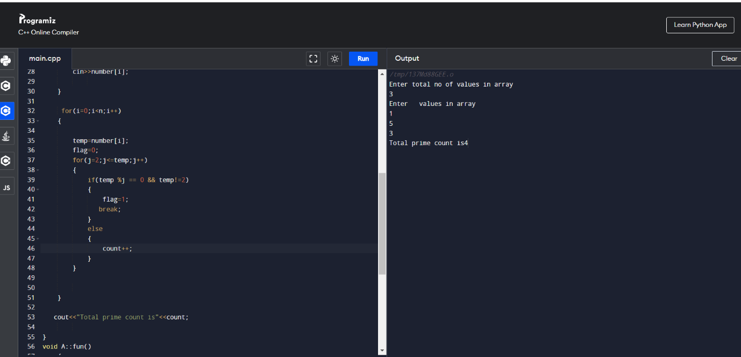

// 26 Check prime numbers iin matrix and print them

//input 6

// 1 2 3 7 9

//output =digits are 1 2 3 7 9

#include<iostream>

#include<math.h>

#include<cstdio>

using namespace std;

class A

{

public:

int arr[3][3],i,j,a;

void getdata();

void fun(int a);

void display();

};

void A::getdata()

{

cout<<"ho";

for(i=0;i<3;i++)

{

for(j=0;j<3;j++)

{

cout<<"\nEnter the number of position "<<i<< " " <<j<<"\n";

cin>>arr[i][j];

}

}

for(i=0;i<3;i++)

{

for(j=0;j<3;j++)

{

a=arr[i][j];

fun(a);

}

}

}

void A::fun(int a1)

{

int temp,flag,k;

temp=a1;

// printf("value of temp is %d\n",temp);

if(a1==1 || a1==2)

{

cout<<a1<<" is prime\t";

}

for(k=2;k<a1;k++)

{

{

if( (temp%k) ==0)

{

// printf("\n %d is not prime",a1);

}

else

{

printf("%d is prime\t",a1);

}

}

break;

}

}

void A::display()

{

//cout<<"ascendig order are\t"<<number[i];

//cout<<i<<"is not aremstrog numbr\n";

}

int main() {

// Write C++ code here

A s;

s.getdata();

//cout<<"values after swap";

//cout<<s.a<<s.b;

return 0;

}

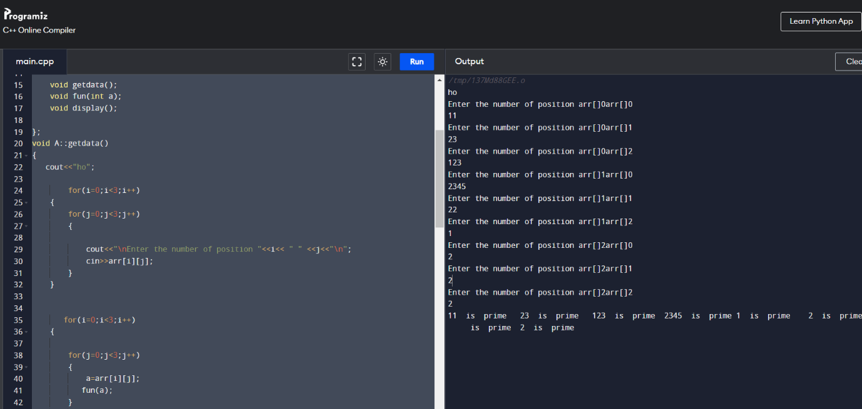

// 27 Check prime numbers iin matrix and print them

//input 6

// 1 2 3 7 9

//output =digits are 1 2 3 7 9

#include<iostream>

#include<math.h>

#include<cstdio>

using namespace std;

class A

{

public:

int arr[3][3],i,j,a;

void getdata();

void fun(int a);

void display();

};

void A::getdata()

{

cout<<"ho";

for(i=0;i<3;i++)

{

for(j=0;j<3;j++)

{

cout<<"\nEnter the number of position "<<i<< " " <<j<<"\n";

cin>>arr[i][j];

}

}

for(i=0;i<3;i++)

{

for(j=0;j<3;j++)

{

a=arr[i][j];

fun(a);

}

}

}

void A::fun(int a1)

{

int temp,sum=0,rem;

temp=a;

do

{

rem=temp%10;

sum=(sum\*10) + rem;

temp=temp/10;

}while(temp!=0);

if (sum == a)

{

printf("%d is pallindrome\n",a);

}

}

void A::display()

{

//cout<<"ascendig order are\t"<<number[i];

//cout<<i<<"is not aremstrog numbr\n";

}

int main() {

// Write C++ code here

A s;

s.getdata();

//cout<<"values after swap";

//cout<<s.a<<s.b;

return 0;

}

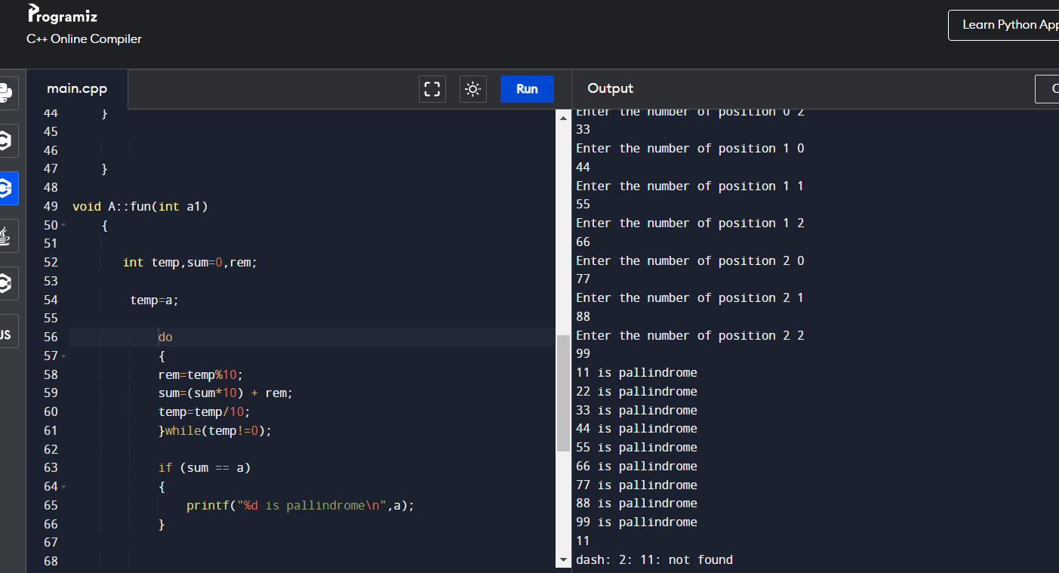

// 28 Armstrong numbers iin matrix and print them

//input 6

// 1 2 3 7 9

//output =digits are 1 2 3 7 9

#include<iostream>

#include<math.h>

#include<cstdio>

using namespace std;

class A

{

public:

int arr[3][3],i,j,a;

void getdata();

void fun(int a);

void display();

};

void A::getdata()

{

cout<<"ho";

for(i=0;i<3;i++)

{

for(j=0;j<3;j++)

{

cout<<"\nEnter the number of position "<<i<< " " <<j<<"\n";

cin>>arr[i][j];

}

}

for(i=0;i<3;i++)

{

for(j=0;j<3;j++)

{

a=arr[i][j];

fun(a);

}

}

}

void A::fun(int a1)

{

int temp,sum=0,rem;

temp=a;

do

{

rem=temp%10;

sum=( sum + (rem\*rem\*rem) );

temp=temp/10;

}while(temp!=0);

if (sum == a)

{

printf("%d is Armstrong\n",a);

}

}

void A::display()

{

//cout<<"ascendig order are\t"<<number[i];

//cout<<i<<"is not aremstrog numbr\n";

}

int main() {

// Write C++ code here

A s;

s.getdata();

//cout<<"values after swap";

//cout<<s.a<<s.b;

return 0;

}

